**Ideation Phase**

**Brainstorm & Idea Prioritization Template**

|  |  |
| --- | --- |
| Project Name | Snack Squad: A Customizable Snack Ordering and Delivery App |
| Maximum Marks | 4 Marks |

**Brainstorm & Idea Prioritization Template:**

Reference: <https://www.mural.co/templates/empathy-map-canvas>

**Step-1: Team Gathering, Collaboration and Select the Problem Statement**

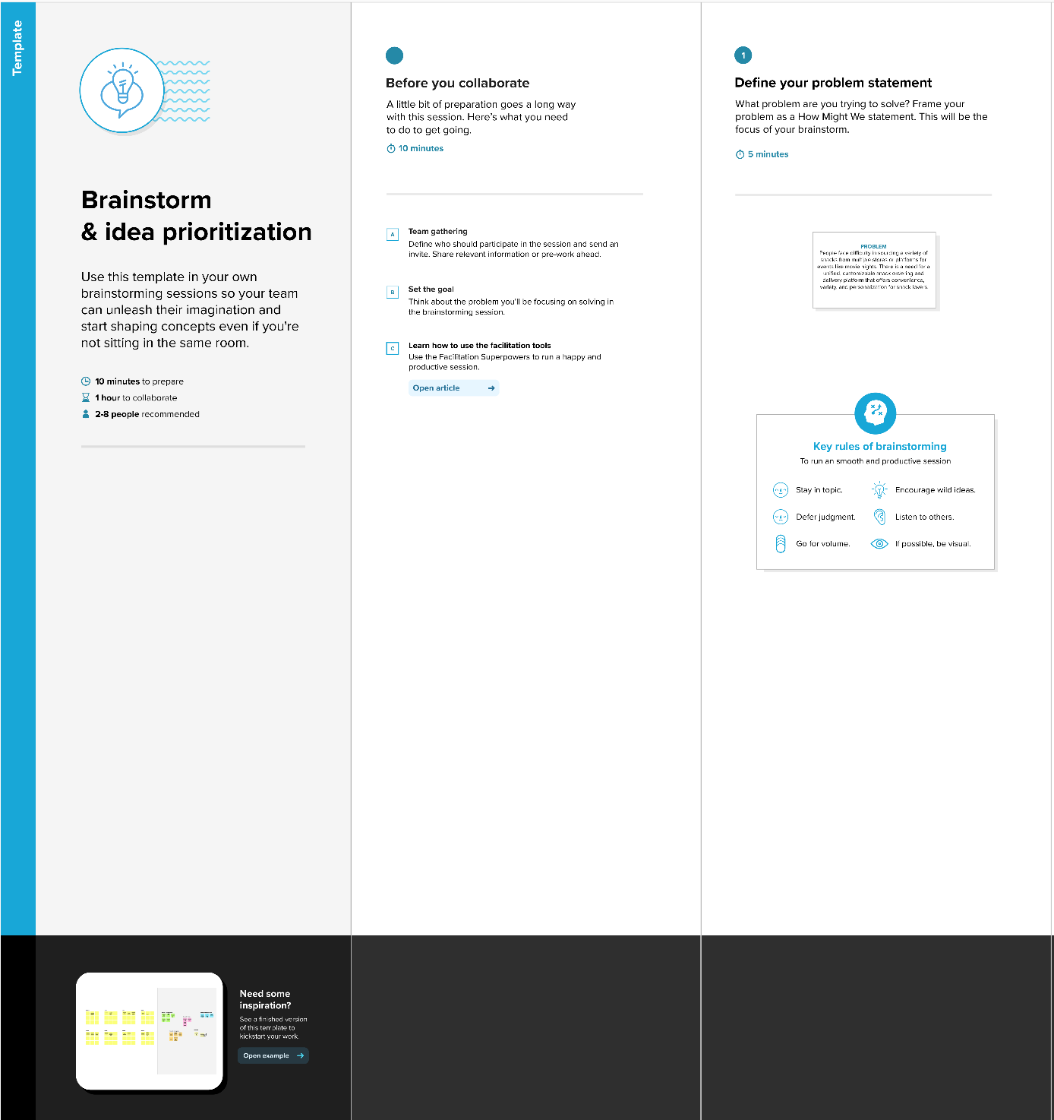

**Step-2: Brainstorm, Idea Listing and Grouping**

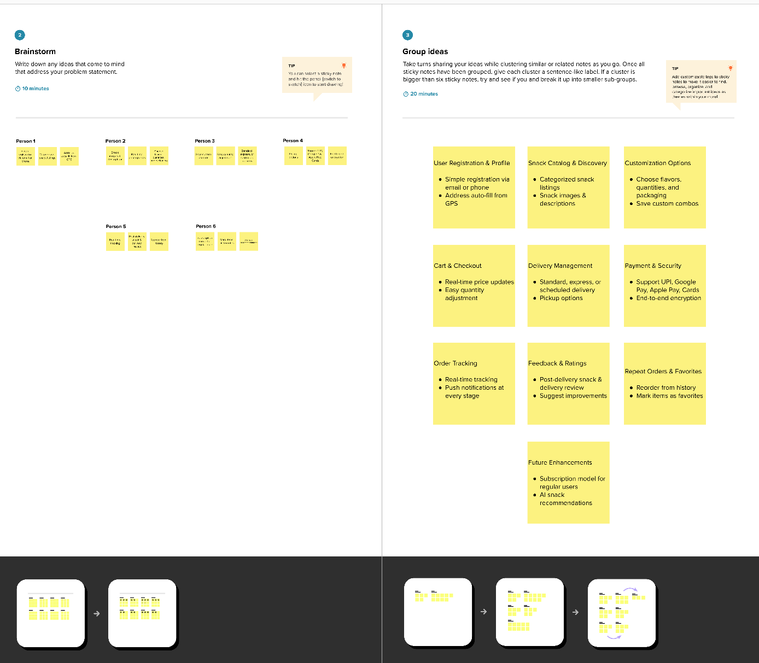

**Step-3: Idea Prioritization**

